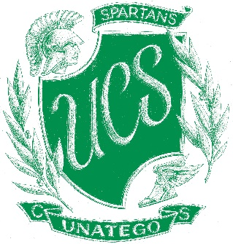

Unatego Central School

Parents’ Bill of Rights for Data Privacy and Security

Unatego Central School is committed to protecting the privacy and security of student, teacher and principal data. In accordance with New York Education Law §2-d, Unatego wishes to inform the community of the following:

- A student's personally identifiable information cannot be sold or released for any commercial purposes.
- Parents have the right to inspect and review the complete contents of their child's education record.
- State and federal laws protect the confidentiality of personally identifiable information and safeguards associated with industry standards and best practices, including, but not limited to, encryption, firewalls, and password protection must be in place when data is stored or transferred.
- A complete list of all student data elements collected by the state is available for public review at http://www.p12.nysed.gov/irs/sirs/documentation/NYSEDstudentData.xlsx, or by writing to the Office of Information & Reporting Services, New York State Education Department, Room 863 EBA, 89 Washington Avenue, Albany, New York 12234.
- Parents have the right to have complaints about possible breaches of student data addressed. Complaints should be directed in writing to the Chief Privacy Officer, New York State Education Department, 89 Washington Avenue, Albany, New York, 12234. Complaints may also be directed to the chief privacy officer via email at: CPO@mail.nysed.gov.
- Unatego will promptly acknowledge receipt of complaints, commence an investigation, and take the necessary precautions to protect personally identifiable information.

Appendix
Supplemental Information Regarding Third-Party Contractors

In the course of complying with its obligations under the law and providing educational services, Unatego Central School has entered into agreements with certain third-party contractors. Pursuant to such agreements, third-party contractors may have access to “student data” and/or “teacher or principal data” as those terms are defined by law.

Each contract Unatego enters into with a third-party contractor, where the third-party contractor receives student data or teacher or principal data, will include the following information:

- The exclusive purposes for which the student data or teacher or principal data will be used.
- How the third-party contractor will ensure that the subcontractors, persons or entities that the third-party contractor will share the student data or teacher or principal data with, if any, will abide by data protection and security requirements.
- When the agreement expires and what happens to the student data or teacher or principal data upon expiration of the agreement.
- If and how a parent, student, eligible student, teacher or principal may challenge the accuracy of the student data or teacher or principal data that is collected.
- Where the student, teacher or principal data will be stored (described in such a manner as to protect data security), and the security protections taken to ensure such data will be protected, including whether such data will be encrypted.

